**Smart therapy**

**Team Members: Supervisor:**

***1. Ahmed Nasser Emmam Eng. Dina Abd el Fattah***

***2. Ahmed Mohamed Mahmoud taha***

***3. Ahmed Abd el Kareem***

***4. Ahmed Mohamed Ahmed***

***5. Ahmed Shaban***

***6. Adham Ibrahim***

***7. Ahmed Nasser Abd el Razik***

**Chapter1**

**Planning**

**Contents:**

Section 1. Project Overview

1.1 Project Description -------------------- 4

1.2 Project Scope ------------------------ 5

1.3 Assumptions ------------------------------ 7

1.4 Constraints ------------------------------ 8

Section 2. Project Start-Up

2.1 Project Life Cycle ------------------------- 11

2.2 Methods, Tools, and Techniques ----- 16

2.3 Estimation Methods and Estimates ---18

2.4 Schedule Allocation -----------------------19

2.5 Resource Allocation -----------------------22

2.6 Budget Allocation --------------------------23

2.7 Network diagram --------------------------

2.8 Gantt chart ----------------------------------

Section 3. Risk Management ------------ 24

Section 4. Appendices -------------------- 26

Section 1:

***PROJECT***

***OVERVIEW***

***1.1) Project Description:***

**It’ s** *an online system that helps users to find their medicine easily wherever they are, because that system locates the nearest pharmacies that have delivery service, it also enables the user to enter the data base of each of these pharmacies and look for any medicine or product he or she wants and finally it also provides a special feature which enables its users to communicate with specialized doctors to ask them about their illness or for any diagnosis*

***1.2) Project scope:***

**First project Includes:**

***1. locates the nearest pharmacies***

***2. View pharmacies medicine database***

***3. communicate with specialized doctors***

***4. Know the number of ambulances in the nearest hospitals***

***5. Delivering medicine to customers***

***6. Live location to track the delivery***

***7. Customer service in the system***

***8. A record of drugs bought by the user***

***9. A reminder for drugs time***

***10. A record for daily blood pressure measurement***

***11. A unique ID for every user***

***12. monthly report about patient***

***13. Submit complaints (About the system)***

***14. Submit complaints (Patient pain)***

***15. Takes feedback from the user (about the system)***

***16. Takes feedback from the user (about the doctor)***

***17. Inquire about bills & pay bill***

***18. Collecting patient info at his medical record***

***19. Selecting doctors***

***20. Store and forward***

***___________________________________________***

**Second Project Excludes:**

***1. Nursing services***

***2. Accessing personal data of each patient***

***3. Change medical staff through the treatment***

***4.*** ***Taking an appointment without matching the queue***

***5.*** ***Generating MR with serious reason***

***6. change of the payment authorizations***

***1.3) Assumptions:***

|  |
| --- |
| ***1. Project need to enhance clinical pharmacist shortage that can help in healthcare practitioners trained to ensure medication-related assistance to hospital personnel and patients.*** |
|  |
| ***2. GPS to know the specific position of ambulance.*** |
| ***3. Clinical Pharmacist Shortage.*** |
| ***4. There is an assessment on every hospital and pharmacy.*** |

***1.4) Constrains:***

**There are some constraints for users who will use this system form clients (patient) or  
even from the employees (medical staff)**

|  |  |
| --- | --- |
| * Clients (patient) | 1. People under age of 18 couldn’t register. 2. This system is only available for those who can afford it. 3. Advertisement content issues 4. Limitations from consumer’s perception 5. Product dosage form confusion 6. Self-medication |
| * The employees (medical staff) | 1. **Database must be update regularly.** 2. **No one could access all data except key persons** 3. **Appointments timetable must be organized based on doctor’s availability.** 4. **All required important data must be send to admin.** 5. **No one can access patient medical records without a strong permission.** 6. **The availability of information about every pharmacy all around the country and should be updated every period of time.** 7. **Mis advertising and misbranding** |

Section 2:

***Project***

***Start Up***

***2.1) Project Life cycle:***

|  |  |
| --- | --- |
| ***1.* Planning Phase:** | **Initial phase of the SDLC process that sets out to discover, identify, and define the scope of the project to decide the course of action and specifically address the issues that are going to be solved by the new system solution. This crucial phase sets the tone for the overall success of the project, which is why it is during this phase that thorough research is performed to determine resources, budget, personnel, technical aspects, and more.** |
| ***2.* Analysis Phase** | **The purpose of this phase is to understand the business and processing needs of the information system project. Here, the development team considers the functional requirements of the system to assess how the solution will meet the end user’s expectations. The end user requirements are determined and documented, and a feasibility study is typically performed to determine if the project is feasible from a financial, organizational, social, and technological standpoint.** |
| ***3.* Design Phase:** | **After a comprehensive analysis phase, the design phase surfaces. In this third phase, the elements, components, security levels, modules, architecture, interfaces and data of the system are defined and designed to evaluate how the finished system will work and what it will look like. The system design is produced in detail to ensure the system will include the necessary features to meet all functional and operational aspects of the project.** |
| ***4.*** Implementation Phase: | **After the system is given a green light from the QA team, it is brought into a production environment. In essence, during this phase, the project is released to be used and/or installed by end users** |
| ***5.*** Testing & Integration Phase: | **This phase involves the Quality Assurance (QA) team who is in charge of performing the overall system testing to determine if the system solution meets the set of business goals and if it performs as expected. Additionally, in this phase, all the different components and subsystems of the solution are brought together to bring the whole integrated system alive. As we’ve discussed in previous articles, testing is becoming increasingly important as it helps ensure customer satisfaction by establishing that the system is fault-free.** |
| ***6.*** Maintenance | **In this final phase, end users can fine-tune the system as necessary to increase performance, add new features and capabilities, or meet new requirements brought to the table by the client. This phase ensures the system remains relevant and usable by replacing old hardware, improving the software, evaluating performance, and applying new updates to make sure it meets all necessary standards and includes the latest technologies to face cyber security threats.** |

***2.2) Methods, Tools and techniques:***

***2.3) Estimation methods and Estimates:***

|  |  |  |  |  |
| --- | --- | --- | --- | --- |
| Description | Estimation | | Most  likely | Source  of the estimation |
|  | **Best** | **Worst** | **Calculated**  **from**  **the formula:**  ***(Best + Worst)***  ***/ 2*** |  |
| Programmers  Effort per week | ***6***  ***tasks*** | ***2***  ***tasks*** | ***4***  ***tasks*** | ***IT***  ***department*** |
| Marketing staff  effort per month | ***4***  ***ads*** | ***2***  ***ads*** | ***3***  ***ads*** | ***Marketing***  ***department*** |
| Number of accounts  Created on the  System per week | ***100***  ***accounts*** | ***50***  ***accounts*** | ***75***  ***accounts*** | ***IT***  ***department*** |
| Budget needed  monthly | ***15000***  ***pound*** | ***20000***  ***pound*** | ***17500***  ***pound*** | ***Finance***  ***department*** |
| Expected earning  monthly | ***30000***  ***pound*** | ***25000***  ***pound*** | ***27500***  ***pound*** | ***Finance***  ***department*** |
| Quality of service rate | ***100*** | ***50*** | ***75*** | ***Customers***  ***Or clients*** |
| Schedule in calendar | ***Have on system***  ***50 doctors***  ***500 accounts***  ***20 pharmacies*** | ***Have on system***  ***10 doctors***  ***300 accounts***  ***10 pharmacies*** | ***Have on system***  ***30 doctors***  ***400 accounts***  ***15 pharmacies*** | ***Project***  ***manager*** |

***2.4)Economic Feasibility study:-***

- Benefit per year = 360000 EGP - recuring cost per year = 247500 EGP

- Discount rate = 9.75% - one time cost = 38500 EGP -

|  |  |  |  |  |  |  |  |
| --- | --- | --- | --- | --- | --- | --- | --- |
| Year of project | | | | | | |  |
| Total | Year 5 | Year 4 | Year 3 | Year 2 | Year 1 | Year 0 |
|  | 360000 | 360000 | 360000 | 360000 | 360000 | 0 | Net economic benefit |
|  | 0.0333 | 0.0657 | 0.1298 | 0.2563 | 0.5063 | 1 | Discount rate |
|  | 11988 | 23652 | 46728 | 92268 | 182268 | 0 | PV of benefits |
|  | | | | | | |  |
| 356904 | 356904 | 344916 | 321264 | 274536 | 182268 | 0 | NPV of all benefits |
|  | | | | | | |  |
| 38500 | | | | | | | One-time cost |
|  | 247500 | 247500 | 247500 | 247500 | 247500 | 0 | Net economic cost |
|  | 0.0333 | 0.0657 | 0.1298 | 0.2563 | 0.5063 | 1 | Discount rate |
|  | 8241.75 | 16260.75 | 32125.5 | 63434.25 | 125309.25 | 0 | PV of cost |
|  |  |  |  |  |  |  |  |
| 283871.5 | 283871.5 | 275629.75 | 259369 | 227243.5 | 163809.25 | 38500 | NPV of all cost |
|  | | | | | | |  |
| 73032.5 | | | | | | | Overall NPV |
|  | | | | | | |  |
| 0.2573 | | | | | | | Overall Roi |

|  |  |  |  |  |  |  |
| --- | --- | --- | --- | --- | --- | --- |
| Year of project | | | | | | |
| Year 5 | Year 4 | Year 3 | Year 2 | Year 1 | Year 0 |  |
| 3746.25 | 7391.25 | 14602.5 | 28833.75 | 56958.75 | (38500) | Yearly PV cash flow |
| 73032.5 | 69286.25 | 61895 | 47292.5 | 18458.75 | (38500) | Yearly overall NPV cash flow |

Breakeven Point occurs at 0.67.

Actual break-even occurred at 0.67 year.

NPV

0.67

Cost

benefit

years

break-even point

***2.5) Resource Allocation:***

* ***Available budget is: 40000 pounds***

|  |  |  |  |
| --- | --- | --- | --- |
| Resources | Price | Set Requirements | Timeframe: s-f |
| project  designer | **2000**  [**EGP**](https://www.currencyc.com/ar/egprates.html) | create the visual elements  that support the system and customer requirements | 18-4-22 to 28-4-22  10 days |
| Database  Developer | 1500 [EGP](https://www.currencyc.com/ar/egprates.html) | design and implement  database for the system. | 18-4-22 to 25-4-22  7 days |
| Programmer | 3000 [EGP](https://www.currencyc.com/ar/egprates.html) | Create, implement and  develop the system – write  and edit code | Every month |
| Database  - administrator | 5000 [EGP](https://www.currencyc.com/ar/egprates.html) | Installing and upgrading the database  Servers and applications | Every month |
| Data base storage | **2000** [**EGP**](https://www.currencyc.com/ar/egprates.html) | Capacity to save and store the database | One time cost |
| 5 computers  Or 5 laptops | **30000** [**EGP**](https://www.currencyc.com/ar/egprates.html) | Test and run the project | One time cost |
| advertiser | **5000**[**EGP**](https://www.currencyc.com/ar/egprates.html) | Advertising the project | 30-4-22 to 20-5-22  3 weeks |

***2.6) Budget Allocation:***

|  |  |  |  |
| --- | --- | --- | --- |
| Number | Key Budget Category | Budget Amount | Period of Time |
| 1 | Team members | 10000 EGP | Monthly |
| 2 | Maintenance | 4000 EGP | Monthly |
| 3 | Data Base License | 5000 EGP | Yearly |
| 4 | Resources | 3000 EGP | Monthly |
| 5 | Transport | 1000 EGP | Monthly |
| 6 | System Censorship | 4500 EGP | Yearly |
| 7 | Improvements of Tools | 4000 EGP | Yearly |
| 8 | Announcements | 1500 EGP | Monthly |

***2.4) Schedule Allocation:***

***2.4.1- Network Diagram:***

|  |  |  |  |  |  |  |  |
| --- | --- | --- | --- | --- | --- | --- | --- |
| # | Tasks | Time in days | | | | Critical  Path | Pre  step |
|  |  | **ET** | **TE** | **TL** | **slack** |  |  |
| 1 | **Meetings with pharmacies** | **4** | **4** | **4** | **0** | ✓ | **---** |
| 2 | **Dealing with doctors** | **4** | **4** | **5** | **1** |  | **---** |
| 3 | **Design the backend and**  **The frontend of the app** | **5** | **9** | **9** | **0** | ✓ | **1,2** |
| 4 | **Programming** | **3** | **12** | **12** | **0** | ✓ | **3** |
| 5 | **Design the database** | **2** | **11** | **12** | **1** |  | **3** |
| 6 | **Connection between**  **Database & the app** | **3** | **15** | **15** | **0** | ✓ | **4,5** |
| 7 | **Create the final product** | **2** | **17** | **17** | **0** | ✓ | **6** |
| 8 | **Implement and test** | **2** | **19** | **19** | **0** | ✓ | **7** |
| 9 | **Add pharmacies accounts**  **And doctors accounts** | **5** | **24** | **24** | **0** | ✓ | **8** |
| 10 | **Release and make**  **advertisement** | **6** | **30** | **30** | **0** | ✓ | **9** |
| 11 | **Take feedback then make**  **Maintenance and**  **optimizations** | **7** | **37** | **37** | **0** | ✓ | **10** |

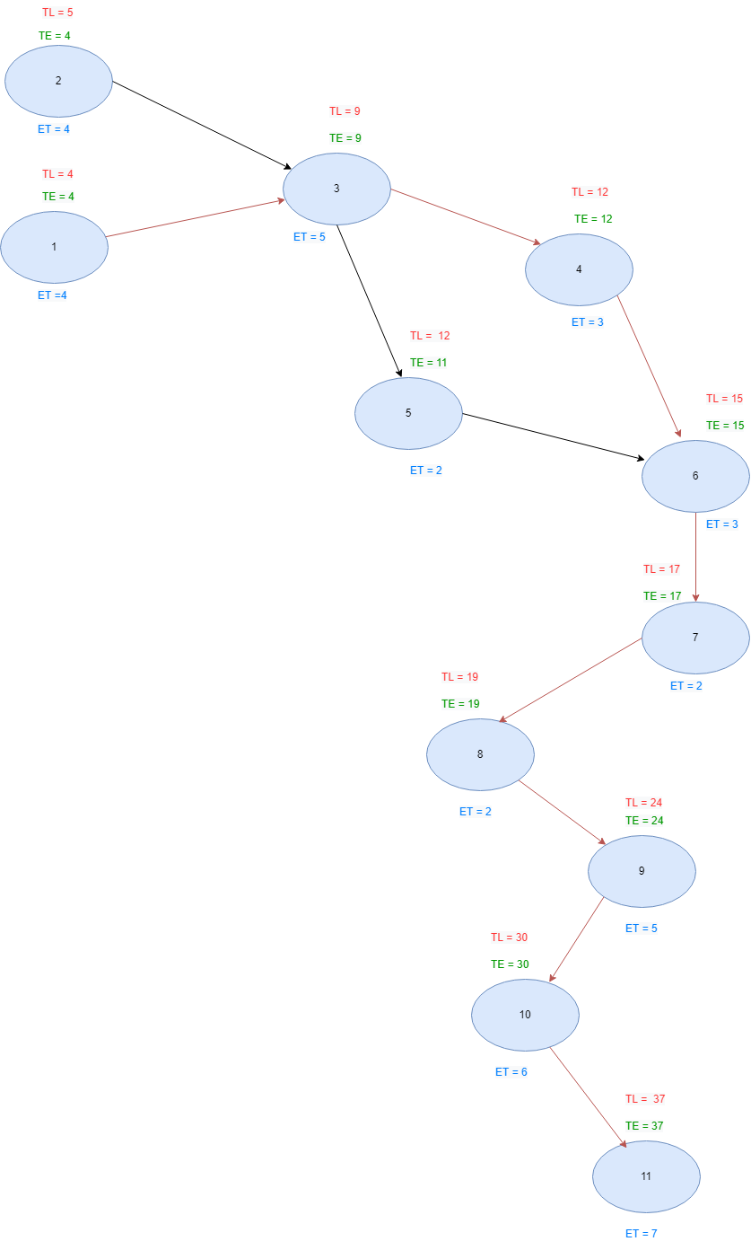

***2.4.2- Chart Diagram:***

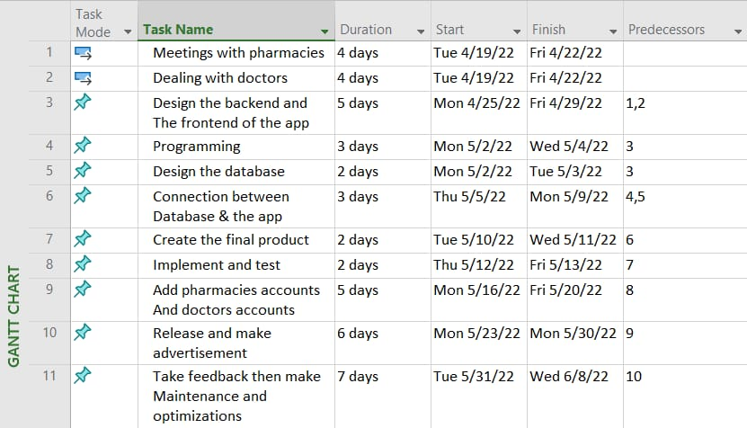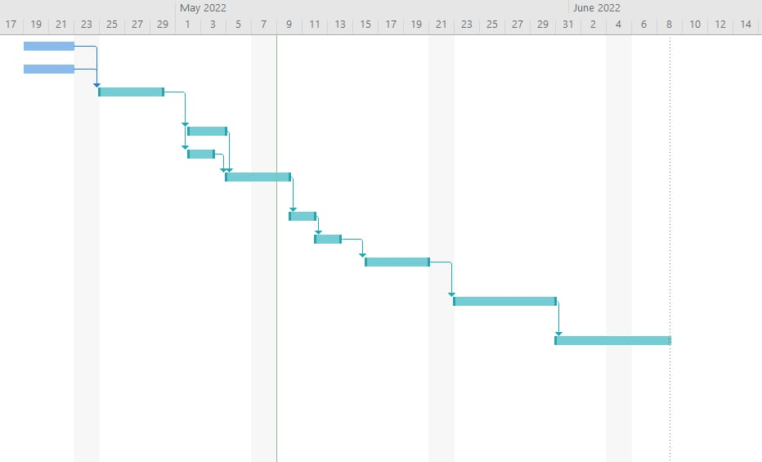

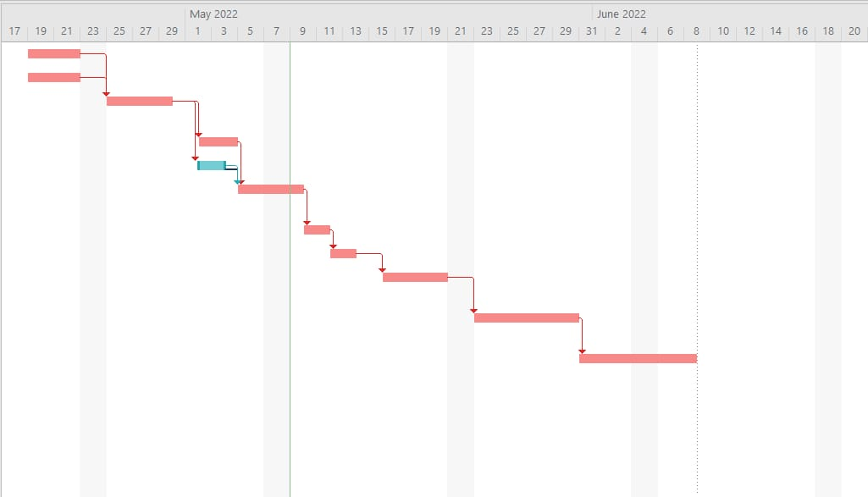

***Section 3:***

***Risk Management***

|  |  |  |  |
| --- | --- | --- | --- |
| **Risk Description** | **Probability** | **Impact** | **Strategy** |
| ***Cost Estimates Unrealistic*** | ***Low*** | ***High*** | ***The cost is the important role in the project that mustn’t change by the time Estimates Unrealistic high the project. (Good study to cost and benefits)*** |
| ***Time Estimates Unrealistic*** | ***Low*** | ***High*** | ***The project must be delivered in the specified time and delaying delivering the project may affect on the importance of the project.*** |
| ***Team Size*** | ***High*** | ***Medium*** | ***If one of the team leave working of the project this will delay the delivered time of the project.*** |
| ***Project Scope Creep*** | ***low*** | ***High*** | ***The scope of the project must review by the project manager to determine the scope of the project requested.*** |
| ***Team Members Unknowledgeable of Business*** | ***Medium*** | ***High*** | ***This effect of the project that does not achieve the requested.*** |
| ***Available documentation*** | ***Medium*** | ***Medium*** | ***The documentation help to make new project or to reengineering the project and it’s very imported.*** |
| ***System failure*** | ***low*** | ***High*** | ***If the Number of users using the system at the same time Has risen more than expected that may cause system failure*** |
| ***Available 24 Hours of medical care*** | ***Medium*** | ***High*** | ***The system should be available 24 hours and provide alternative care in case of technology malfunction*** |
| ***All Doctors are busy*** | ***low*** | ***medium*** | ***In some health cases immediate Consulting should be provided to the Patient*** |
| ***Delay in delivering medicine*** | ***High*** | ***High*** | ***Due to traffic congestion at peak times, the delivery of medication to the patient may be delayed*** |
| ***The disease is not clearly described*** | ***Low*** | ***High*** | ***As the Doctor should inquire clearly about the illness in some cases it may be misunderstand*** |
| ***Available medical record*** | ***Medium*** | ***Medium*** | ***The interaction between patient and doctor using the telehealth monitoring technology should be recorded in the medical record of the patient.*** |

***Section 4:***

***Appendices***

* ***There will be a new feature downloaded on the application every month***
* ***This application is made with the help of a specialized staff of doctors and pharmacists***
* ***To make use all the features of that app you have to read ‘project scope’ part very carefully***

**Chapter2**

**Analysis**

*Questionnaire*

***For whom:*** number of users

***Date: 5 / 4 / 2022***

*1) Did you choose the program as the primary means of diagnosing disease and obtaining the medicine?*

2)*How did you find the service while using the program?*

3) Do you find it easy to use the program?

4) what would you want to change or add?

-Add more pharmacies and more payment methods.

* ***What did we obtain from this Questionnaire?***

1)That we must update the program and make it easier to use.

2) Add more payment methods to make it easier for the users to pay.

***Interview num1***

*Interviewee’s Name:* ***Abdelrahman Rashawn*** *Date:* ***6/4/2022***

*Position:* ***engineer*** *Time: -* ***03:00 pm***

*Position Location:* ***Cairo*** *Interviewer:* ***Ahmed Mohamed***

1. Describe your experiences with the program

***Answer:*** very useful program that help me to diagnosing a disease and knowing the best treat

1. Tell us how you can use the program?

***Answer:*** the program is easy to use because there are thousands of diseases and its diagnoses, I can know what is my disease by search for the effects that I feel and knowing the best treat

1. Describe a task ….

***Answer:*** order a medicine online and its delivers to my house

1. What are your expectations of the new system?

***Answer:*** it will provide a new feature like you can consulting a doctor and booking a room at hospital

***Chapter3***

***Design***

***1)DFD ( Data Flow Diagram)***

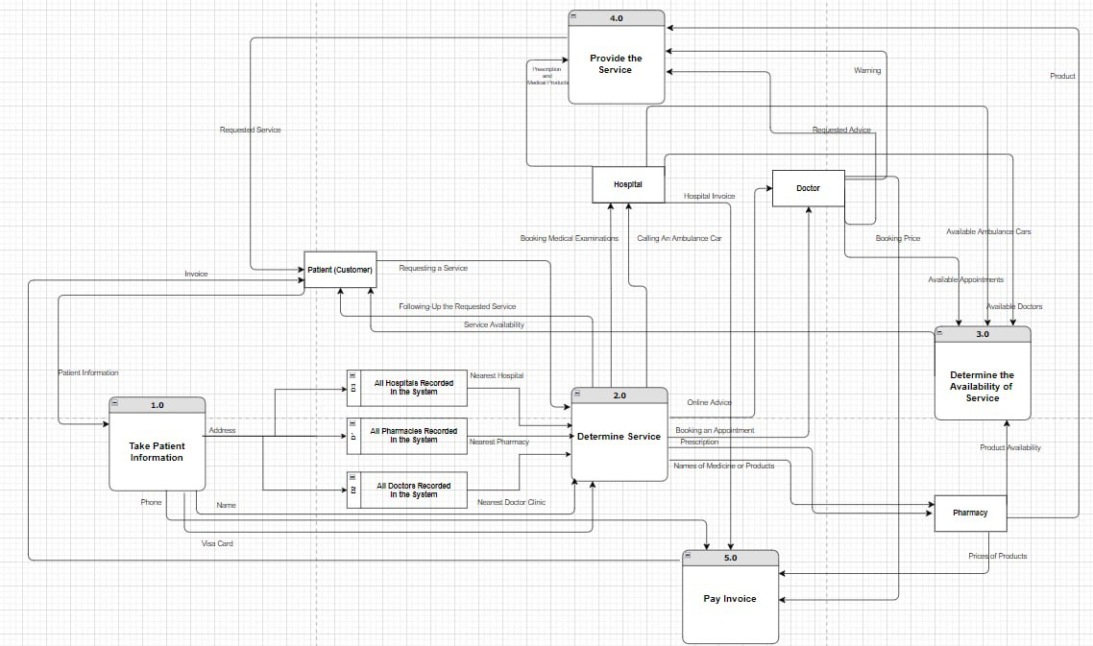

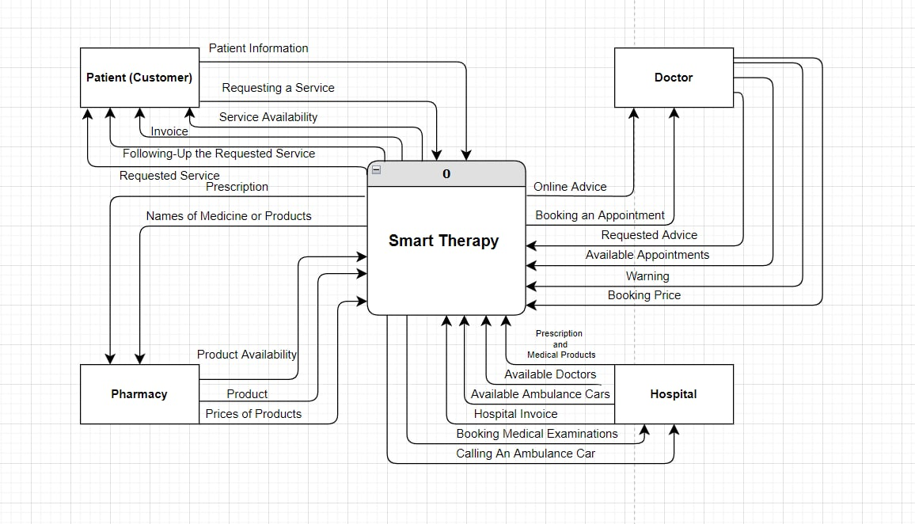

**2)ERD (Entity Relationship Diagrams)**

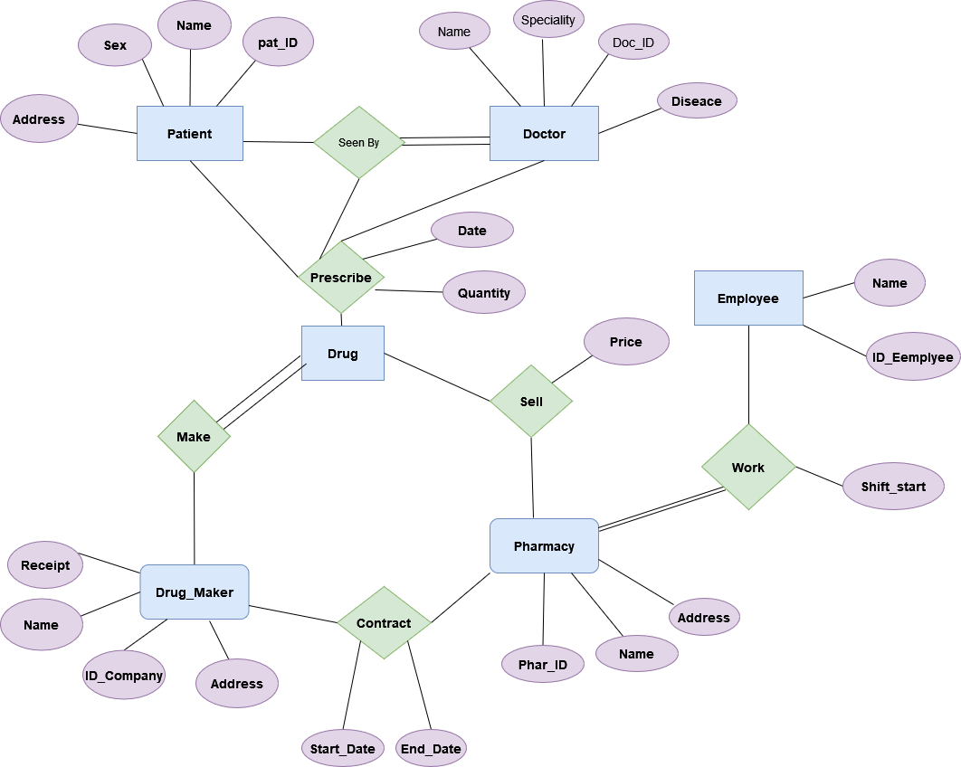

***Mapping:***

**Patients**

|  |  |  |  |  |
| --- | --- | --- | --- | --- |
| Pat_ID | Name | Address | Sex | Disease |

**Doctor**

|  |  |  |
| --- | --- | --- |
| Doc_ID | Name | Specialty |

**Drug Maker**

|  |  |  |  |
| --- | --- | --- | --- |
| Drug_ID | Name | Address | Receipt |

**Pharmacy**

|  |  |  |
| --- | --- | --- |
| Pha_ID | Name | Address |

**Employee**

|  |  |
| --- | --- |
| Emp_ID | Name |